**Functions in JavaScript**

**JavaScript functions:**

A function in JavaScript is a block of code, used to perform a specific task so whenever we want to perform some specific task, we create a function. It’s consider a [first class functions](First%20class%20&%20higher%20order%20functions.docx).

**Why Functions? Functions are created:**

* To divide a larger problem into smaller tasks or modules (manageability).
* for **reusability** (I.e. once a function is defined, it can be used multiple times)
* For **abstraction** (I.e. hiding the way how tasks are done) (creating libraries).

**Creating a function:**

There are many ways in which we can create a function in JavaScript

1. Using [function **declaration**](Function%20declaration.docx)
2. Using [function **expression**](Function%20expression.docx)
3. Using [function **constructor**](Function%20constructor.docx)
4. Using **IIFE** ([Immediately Inviolable Function Expression](Immediately%20Inviolable%20Function%20Expression.docx))

[**Types of JavaScript Functions.docx**](Types%20of%20JavaScript%20Functions.docx)

**Important notes on functions:**

1. What happen inside the function stay inside the function.

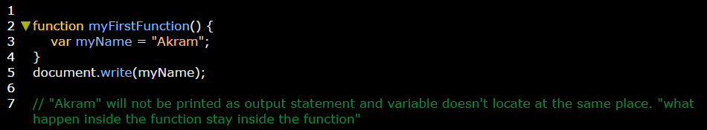

1. You can invoke the function on html by the events.

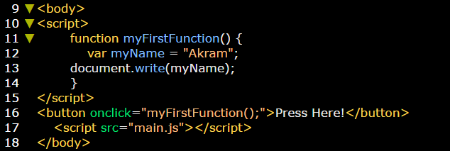

1. Use **arguments** keyword within function body to see all parameters that passes to the function:

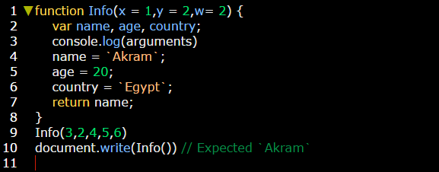

**Output in console is:**

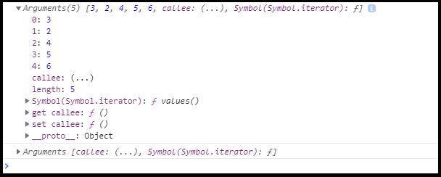

**Note:** if you write arguments statement outside function body, Error will returns.